Support Life Sunday 2021: SUPPORTING AND HONOURING HEALTH CARERS
Every day we witness the testimony of courage and sacrifice of healthcare workers.
Pope Francis: Message for International Nurses Day 2020

“Supporting and honouring health carers” is the theme of Support Life Sunday on 10 October. This year’s focus acknowledges the work of health carers, including family carers and health professionals, who are on the frontline in supporting and protecting life.
The change of name and focus to Support Life Sunday recognises that we need to move beyond political debate or legal argument and extend to active, practical support for people facing a range of life challenges at the beginning of life, throughout life, and at the end of life.
Health carers are currently under intense pressure because of the Covid-19 pandemic, as well as experiencing the impact of recent changes to New Zealand’s abortion and euthanasia legislation. Health carers are also witnesses to the ongoing impact on health and life of poverty, exclusion, attitudes towards disabilities, and addictions.
Pope Francis has acknowledged and thanked health carers in many statements throughout the Covid-19 pandemic. This year’s Support Life Sunday resources share the stories of health carers who are examples of people who support life in their homes, jobs and careers. Each of our parishes and communities has many such examples. This is an opportunity to acknowledge and support those who support life.
The Support Life Sunday resources have been prepared by the Catholic Bishops' Nathaniel Centre for Bioethics and are online here: https://www.catholic.org.nz/resources/support-life-sunday-2021
The resources include:
Liturgical material: To assist parishes and communities, including households and families at home in bubbles, to celebrate Support Life Sunday. This material has been prepared in partnership with the National Liturgy Office and includes prayers, reflections and children’s liturgy suggestions.
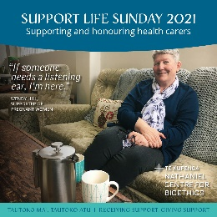
Health carer stories:
Wendy Hill supports pregnant women through listening and accompaniment as she works to make pregnancy a possible path for people to take.

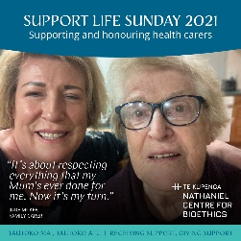
Jude McKee supports her mother with dementia as a family carer at home.

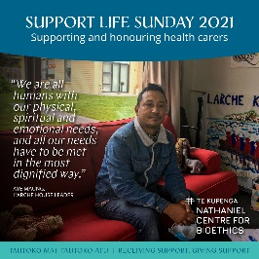
Aye Maung lives in the L’Arche community of people both with and without intellectual disabilities, and recognises the dignity of all.

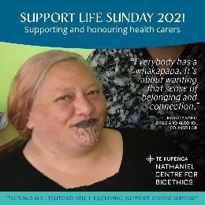
Hariata Kahu is drug and alcohol counsellor at Te Tai o Marokura health and social services an supports people with addictions to make changes to save their own lives.

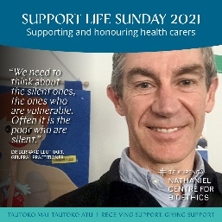
Dr Bernard Leuthart is a general practitioner who supports people with long-term health conditions and people at the end of life.

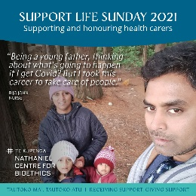
Bijo John is a nurse who has worked in community and hospital settings and sees the pressure that Covid-19 is placing on the community and the health workforce.

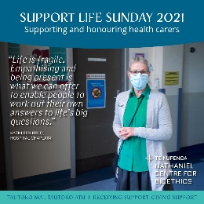
Kathleen Field is a hospital chaplain who accompanies people during difficult and challenging times of their lives.

Posters and social media tiles are available to download
A powerpoint including health carer quotations and inspirational quotes from Pope Francis is also available to download.

