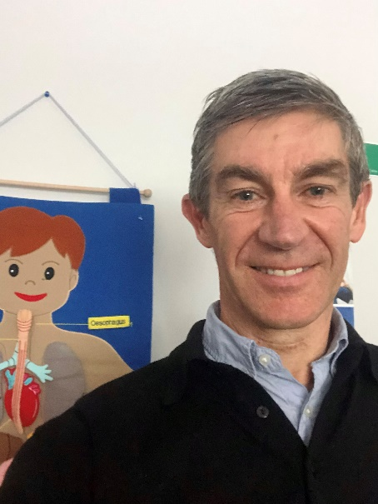
Bernard Leuthart, General Practitioner: Supporting the life of the vulnerable
Dr Bernard Leuthart is a general practitioner and clinical director at Tui Ora, a Whānau Ora health and social services provider in New Plymouth. “There are aspects of the work that I’ve chosen that are specifically about supporting the life of the vulnerable.”
The majority of the patients he sees everyday have long-term conditions such as respiratory disease, diabetes and heart disease. “In our organisation we’re about trying to aim for health outcomes that are equitable in some way, and we’re up against 200 years of miserable failure to make an equitable approach for Māori.”
Bernard says that building up trust so that people feel they are able to take some control of their health themselves takes time. “It’s trying to work through a process where you hand the patient back to themselves and they say, ‘Oh, look, I got myself well,’ and the doctor fades into the background.”
He currently works close to where he grew up and went to school at Francis Douglas College. It is also close to one of the poorest communities in New Zealand. “I grew up, 200 to 300 metres away from people with a completely different life trajectory. Part of the hard task of doing general practice, or teaching, or any of the helping ministries is having the disposition of the preferential option for the poor.”
He sees changes due to Covid-19 lockdowns and restrictions as having had impacts on low-income people in precarious work. “There’s a fund for business, but what’s not well covered is always the bottom layer of folk who were on tenuous work anyway, and then suddenly that’s not there.”
While Bernard enjoys general practice, he also really appreciates the opportunities he has to support people in palliative care. “I love the end of life, I’ve always seen it as hopeful.” He aims to support people to have a good death, a beautiful death.
“There’s an opportunity we get in death to focus on life, on supporting life.” Often in palliative care Bernard visits people in their homes. “I love going into a home, I like the fact that people are disarmed, they’re bringing you into their space and weirdly, in their attempt to make you comfortable, they get more comfortable.”
One of the challenges for Bernard is the upcoming implementation of the End of Life Choice Act. “Of course I’ve written submissions and have been steadfastly in support of life, and not of death by your own hand. So I’ve got a very particular view on that, and that’s known.
“But it’s a challenge to talk to colleagues and look at what our response will be as an organisation to people requesting to end their own lives. It’s about carrying the weight of that as we try to deliver to people in an authentic way that gives respect to them and their decisions but also fundamentally respects what we believe. So it’s been very challenging, but also good. It’s enabled me to look at the fundamental dignity that attends the work we do.”
Bernard believes that communities could better attend to silence. “Thinking about the silent ones, the ones who are vulnerable. It’s kind of easy to focus on the issues, like abortion or end of life choice, and they’re hugely valid things to focus on, but it’s harder to focus on the vulnerable poor. You know, the big Jesus mission. And often it’s the poor that are silent or their needs are silent.”
He sees that many people in the community have struggled through Covid-19 lockdowns and restrictions but overall he has been amazed at people’s resilience. However, many health carers are facing burnout and compassion fatigue.
“The community can really help to support health carers by the work that’s done in public spaces to support good initiatives like the vaccination programme, and getting behind supporting nurses. Also by supporting tools that give an uplift to a person, and in my work, one of that ways we’re supported is by hearing lots of reo, hearing lots of Māori language.”
Bernard says having a faith dimension and a supportive family are protective factors for him. “I try and focus on one person in front of me at a time, that’s just the thing I can do.”

