Bijo John, Nurse: Whatever I can do, I do
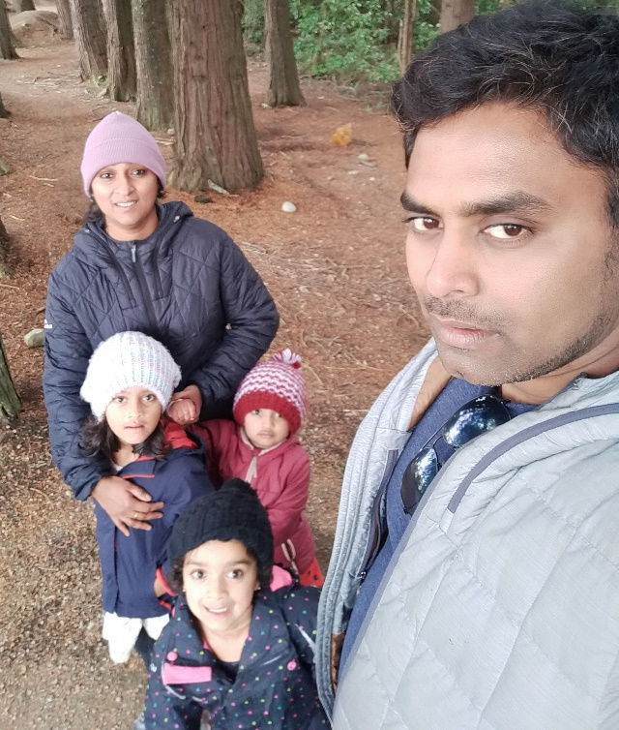
Bijo John trained as a nurse in India and New Zealand, and has worked in both hospital and community nursing settings. He regards it as a privilege. “Being a health care worker can have a big impact on people.”
His current work is in a community health service, where the help he is able to give often goes beyond medical assistance.
“Here you see people who don’t have food, who don’t have insulation, who don’t have money to pay their rent or heating, which all makes them sick.” He is able to refer people to foodbanks, community health workers and agencies which help with making houses warmer. “Health services can make a lot of changes in people’s lives.”
He draws on his faith from his Catholic upbringing in responding to people, especially the identification of Christ with people in need; I was thirsty and you gave me water. “So there is a connection from the Bible to care, but for me it’s more about humanity. I look to Jesus Christ who was a man and taught us to love people. He was there to help people humbly, supporting them.
“He multiplied the bread and fish, and he didn’t care what sort of people were sitting there. He fed them all. It’s for everybody. I’m a human being too, I follow his example to support people in their need.”
However, Bijo says it is a stressful time to be a health carer. “When I leave home, I dedicate myself to my work. Sometimes it’s like getting ready for war. It’s like becoming a different person to serve the nation, to serve the community.”
He said in a time of Covid-19, health care staff don’t know what new situations they are going to come across. “There is a fear. Being a young father, thinking what’s going to happen if I get Covid? What about my family.” He has three daughters aged 6, 3 and 2-years-old.
However, he said there are many health care workers in New Zealand who are also having a hard time. “The New Zealand healthcare system is understaffed, and depends a lot on migrant health care workers, but there is a scarcity of migrant workers at the moment. Those who are here can’t go home, but they are thinking about home. Some can’t get married, everything’s up in the air for them. Covid has definitely put mental, social and physical stress on all age groups in the medical profession.”
However, he said he is glad that there is recognition of the stress on health care workers. “A word of appreciation, a card, someone leaving food or speaking to the manager, saying, ‘Thanks for looking after the community’ – it can really make you feel valued.”
He also likes to talk to people, to take a bit of extra time to listen to people’s own struggles and challenges. “You are here at work for 8 hours, and you want to be productive, so you want to support people. I know I took this career to take care of people. Whatever I can do, I do.”

