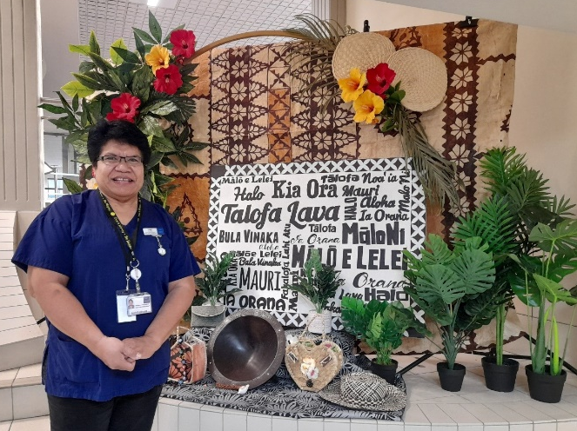
Sr Lusini Falemaka: Health is part of our being
Sr Lusini Falemaka sees a lot of fear in the community about health concerns. “People have a lack of health knowledge, and they have a fear of the unknown, of this new sickness, this Covid-19, a sudden thing that’s come into our life.”
She has practised as a nurse for over 30 years, training in Tonga before joining the Sisters of St Joseph of Cluny and subsequently doing further training in New Zealand. Her work has included over 10 years working in the acute medical ward, and four years working in the Fanau Ola team at the Pacific Health Development, under the umbrella of Counties Manukau Health.
Since the Covid-19 outbreaks began in 2020, she has worked in Managed Isolation and Quarantine, Covid-19 screening and Covid-19 vaccinations.” I believe that what I do as a nurse is to protect life.”
Sr Lusini says working with the Pasifika community gives her an opportunity to teach people and encourage them to make choices for the good of all. “People need to have the right information. For us as health professionals, we need to give the right health information at the level and in the language that people can understand.”
Working to give vaccinations in Ōtara, at the centre of the August/September Covid-19 outbreak in Mangere, she sees that while people are now rushing to get vaccinated, they still don’t understand what is going on or what to do to protect themselves and their families. “It’s a fear of death, a fear of the unknown. People are learning the hard way.”
Sr Lusini says extra efforts are needed to ensure Pasifika people are able to access the same healthcare as other New Zealanders. She believes some of that could happen by establishing healthcare teams in parishes, recognising that many clergy also don’t have much first-hand knowledge of the New Zealand health system.
“We could have something solid in each parish, with people that parishioners can trust, to speak of healthcare and things relevant to them, especially at this time of the Covid.”
She sees that many parishes are now strong on social issues and would like to see health given the same attention. “Health is part of our being. It needs to be recognised,” she says.
The impact of the Covid-19 pandemic on Pasfika communities is the most recent of ongoing health challenges affecting Pasifika communities. Sr Lusini says over several decades there has been a big influx of Pasifika people who migrated to New Zealand for work, often holding low-income jobs, and living in cold and overcrowded homes, who are often not able to communicate in English and are not familiar with the health system.
“This kind of environment contributes to make a person unwell. A low income does not help a person to be able to afford a comfortable house or a balanced diet.”
However, she sees progress in programmes which partner Pasifika health professionals with students, often mentoring them through from secondary school, through healthcare training and even up to the first few years of their working careers.
“It is important to employ more Pasifika clinicians, who understand the language, culture and customs. In health, communication is very important to bring the rapport so that the trust may build.”
She draws on her Catholic upbringing as the source of her commitment to protect life. “My belief in God, the environment where I grew and developed, and my choice of nursing as my witness as a Catholic sister, have given me the conviction that what I do is protecting life.”
Sr Lusini says the values of the Counties Manukau Health environment in which she works also contributes: “Valuing everyone by making them feel welcome and valued. Show kindness by taking care of other people’s wellbeing. Working together, including everyone as part of the team and excellence in safety. Professional and always improving. These are the foundational values for their work. The environment where I work at the moment also helps me to protect life.”
She says the wider community can support health carers through prayer, and through recognising and acknowledging the contribution of Catholic health care professionals. “Health carers need God’s guidance and blessings daily. They also need to be acknowledged for what they do.
“I’m open to help where I’ve felt there is need. My witness is who I am, working where I am. I’m Tongan and a Catholic sister. I’m human and I protect life.”

