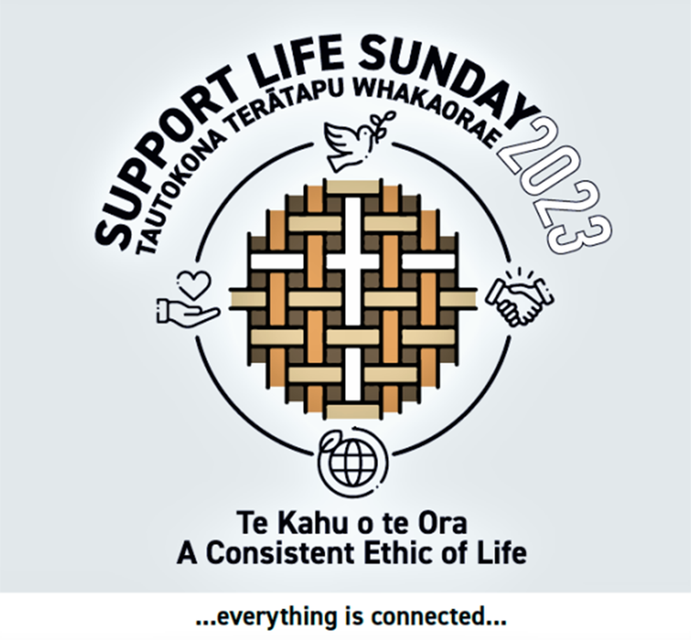
Messaging for Support Life Sunday 2023
The concept of a Consistent Ethic of Life – Te Kahu o te Ora is grounded in the conviction that all God’s creation is sacred and that all life issues are closely connected. It also lays down the wero - challenge - to look at the world in an integrated way and to critique not just our relationships with other persons and with God but with all of creation.
Everything is connected.
Read the NZ Catholic Bishops revised version of Te Kahu o te Ora here:
https://www.catholic.org.nz/assets/Consistent-Ethic-of-Life-booklet-26-September-2023.pdf

Addressing sexual violence/abuse involves a commitment to fundamental structural change: reforming gender inequities, promoting power sharing, and facilitating greater inclusion, safeguarding, transparency and accountability at the highest governance levels of our institutions, starting with the Church. Sexual violence/abuse is enabled by attitudes which both foster, and fail to challenge, authoritarian structures that lead to the dominance of the strong and powerful over others.
#everythingisconnected

Microplastics have been detected in the placentas of unborn babies and in breast milk. Their potential effects include reduced foetal growth. It is well known that we are all consuming the tiny particles via food and water, including formula milk from plastic bottles, as well as breathing them in. These microplastics, which are traceable to packaging, paints, cosmetics, synthetic clothing and carpets, personal care products and more, have reached every part of the planet, including the most vulnerable of our human species.
#everythingisconnected

A commitment to peace means generously welcoming and providing ongoing support for those who have fled their homelands because of warfare. Wars lead to the displacement of millions of people every year. Opposition to the violence of war requires a parallel commitment to open our borders to refugees and provide long-term assistance for them to settle and address traumas.
#everythingisconnected

Respect for the God-given biodiversity of our world and the survival of species, which is closely connected with the integrity of food chains, requires that we urgently change our personal habits of consumption and wastage of natural resources. The choices we make about travel, food and drink, clothing and lifestyles are directly linked to the survival of fragile ecosystems. Human use of earth’s resources has far outstripped the capacity of our planet. The combined impact of the burning of fossil fuels, destruction of forests, stripping of oceans and unhealthy farming is rapidly destroying the rich biodiversity of our earth.
#everythingisconnected

Supporting a fair living wage and promoting job security and worker rights upholds human dignity and well-being and is a positive factor in families finding a way out of poverty. Around half the children in Aotearoa in material hardship come from working households. Poverty impacts negatively on the well-being of children, including educational and other developmental outcomes.
#everythingisconnected

Comprehensive, practical, family-support policies enhance individual and family well-being, give parents additional options and save lives that might otherwise be lost to abortion. A lack of accessible societal supports for families, including pressures related to the costs of housing, living and childcare, can be a significant contributing factor to having an abortion.
#everythingisconnected

Urgent action towards the escalating climate crisis will save human lives and is a fundamental expression of the sanctity of all God’s creation. The climate crisis is the biggest health threat facing humanity. The World Health Organisation reports that it is expected to cause approximately 250,000 additional deaths per year from malnutrition, malaria, diarrhoea and heat stress in addition to deaths caused directly by adverse weather events such as wild-fires, cyclones and typhoons.
#everythingisconnected

Socially connected people live longer, are less likely to be depressed, have a lower risk of developing dementia and are less likely to suffer from hypertension or heart disease or have a stroke. Loneliness/social isolation, which is growing amongst older people, is linked with a significantly reduced likelihood of survival of death from all causes. It is also a driver for euthanasia.
#everythingisconnected

Addressing the growing economic disparity between rich and poor through effective government policies will improve health outcomes and save lives. Research shows that people from poorer areas are 1.6 to 2 times more likely to die after a cancer diagnosis than those who are well off.
#everythingisconnected

The right to life means giving greater visibility, voice and power to a disability perspective – recognising and removing the attitudinal and physical barriers to acceptance and inclusion experienced daily by disabled people, within the church and beyond. Disabled people experience many barriers and exclusions and are disproportionately represented in abuse statistics.
#everythingisconnected
The prevention of warfare through non-violent resolution of conflicts is an act of respect for all of God’s creation. Warfare inflicts irreparable damage on the environment, destroying wildlife and ecosystems while leaving toxic and life-threatening waste in the form of chemicals, landmines and general destruction of homes and livelihoods.
#everythingisconnected

Recognising, articulating and reforming the structural racism and discrimination in our societal institutions will improve health outcomes and save many lives while enhancing the well-being of many others. The impacts of colonisation mean that, statistically, Māori have a diminished life expectancy, poorer health and educational outcomes and higher rates of incarceration than other ethnic groups in Aotearoa.
#everythingisconnected
A Consistent Ethic of Life – Te Kahu o te Ora reflects our belief that the protection and promotion of life requires a concern for the broader issues in society. One aspect of life affects another. All are important.
Everything is connected.
Read the NZ Catholic Bishops revised version of Te Kahu o te Ora here: https://www.catholic.org.nz/assets/Consistent-Ethic-of-Life-booklet-26-September-2023.pdf

