**Māori Language Week – Te Wiki o te Reo Māori**

September 12, 2022 - September 18, 2022

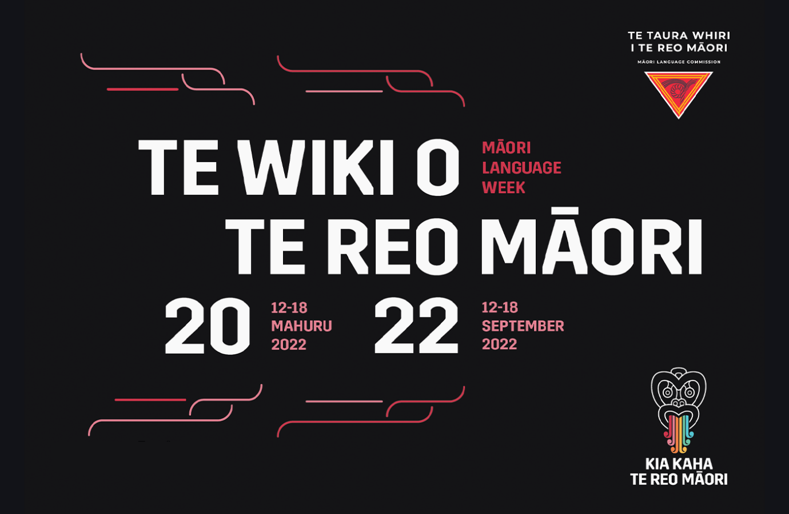

*E te iwi whakapono tēnā koutou, tēnā anō tātou katoa.*

It’s that time again, so ***kia ora*** and let’s use and promote te reo Māori.

Te Wiki o te Reo Māori has been celebrated in Aotearoa since 1975. In 2022 Māori Language Week takes place 12 to 18 Mahuru, September.

This special week is an opportunity for the concentrated celebration and promotion of te reo Māori, helping to secure its future as a living, dynamic, and rich language.

Attached are some resources and bits and pieces, *he pitopito kōrero*, to inspire our *hīkoi*.

**What is Māori Language Week?**

New Zealand has its very own language, Māori! Along with English and NZSL (New Zealand Sign Language), te reo Māori is has been an official language of Aotearoa since 1987.

Every year Māori Language Week is held to promote the indigenous language and celebrate the culture.

New Zealanders are encouraged to learn some te reo Māori and are given the chance to experience the culture with events scheduled around the country.

**When is Māori Language Week?**

Māori Language Week is celebrated annually in September starting on a Monday and ending on the following Sunday.

**Te reo Māori tips**

There are 15 distinct sounds within the te reo Māori alphabet. They are:

* 5 vowels                **a, e, i, o, u**
* 8 consonants        **h, k, m, n, p, r, t, w**
* 2 digraphs (two letters that combine to form one sound)

**wh, ng**

**Macrons**

A vowel can also have a long or short sound.

A long sound usually has a ‘macron’.

A bar over a vowel to indicate it is lengthened during pronunciation e.g. **ā** as in **wāhi**.

However some tribal areas prefer the use of **double vowels** rather than macrons i.e.  **waahi**.

Most consonants are pronounced the same as in English, except **T** and **R**.

* **T** - The t sound varies depending on which vowel comes after it. When followed by an ‘a’, ‘e’ or ‘o’, it’s pronounced with little or no 's' sound.  When followed by an ‘i’ or ‘u’, it includes a slight 's' sound, however not nearly as much as an English ‘t’.
* **R** - Pronounced as a soft ‘rolled’ r. Similar to the ‘d’ sound in English. The ‘ng’ digraph is pronounced as it sounds in the English word ‘singer'. The ‘wh’ digraph originally sounded like the ‘wh’ in ‘whisper’, but in most dialects has evolved to be more like the English ‘f’ sound.

**The History of Māori Language Week**

**A language lives**

Despite the emphasis on speaking English, the Māori language survived. Until the Second World War most Māori spoke te reo as their first language. They worshipped in Māori, and Māori was the language of the marae. More importantly, it was still the language of the home, where parents passed it on to their children. Political meetings, such as those of the Kotahitanga parliament in the 1890s, were conducted in Māori; there were Māori newspapers; and literature such as Apirana Ngata’s waiata collection, Ngā mōteatea, was published in Māori with English translations.

The language that Māori spoke was changing. All living languages are influenced by the other languages their speakers hear. English became the major source of borrowed words, which were altered by Māori usage to fit euphonically and grammatically.

Loan words such as *teihana* (station) and *hōiho* (horse) are called transliterations, Some transliterations were unnecessary. Māori had perfectly good names for places like Napier (Ahuriri), but sometimes transliterations of the European names, such as *Nepia* (Napier) and *Karauripe* (Cloudy Bay), were used. The English language in New Zealand was also changing and borrowing words from Māori or Polynesian languages, such as taboo (tapu), kit (*kete*) and *Kiwi* (a New Zealander).

**The lure of the city**

The Second World War brought about momentous changes for Māori society. With plenty of work available in towns and cities, Māori moved into urban areas in greater numbers. Before the war, about 75% of Māori lived in rural areas. Two decades later, approximately 60% lived in urban centres.

English was the language of urban New Zealand – at work, in school and in leisure activities. Māori children went to city schools where Māori was unknown to teachers. Enforced contact between large numbers of Māori and Pākehā caused much strain and stress, and te reo was one of the things to suffer.

The number of Māori speakers began to decline rapidly. By the 1980s fewer than 20% of Māori knew enough te reo to be regarded as native speakers. Even for those people, Māori was ceasing to be the everyday language in the home. Some urbanised Māori people became alienated from their language and culture. Others maintained contact with their original communities, returning for important hui (meetings) and tangihanga (funerals), or allowing the *kaumātua* at home to adopt or care for their children.

**Seeds of change**

From the 1970s many Māori people reasserted their identity as Māori. An emphasis on the language as an integral part of Māori culture was central to this identity. Māori leaders were increasingly recognizing the danger that the Māori language would be lost. New groups with a commitment to strengthening Māori culture and language emerged in the cities.

**Māori language petition, 1972**

In 1972, three of these groups, Auckland-based Ngā Tamatoa (The Young Warriors), Victoria University’s Te Reo Māori Society, and Te Huinga Rangatahi (the New Zealand Māori Students’ Association) petitioned Parliament to promote the language. A Māori language day introduced that year became Māori language week in 1975. Three years later, New Zealand’s first officially bilingual school opened at Rūātoki in the Urewera. The first Māori-owned Māori-language radio station (Te Reo-o-Pōneke) went on air in 1983.

Major Māori-language recovery programmes began in the 1980s. Many were targeted at young people and the education system. The kōhanga reo movement, which immersed Māori pre-schoolers in the Māori language, began in 1982, when the first kōhanga reo opened in Lower Hutt. Other programmes followed, such as kura kaupapa, a system of primary schooling in a Māori-language environment.

**The ‘Kia ora’ controversy**

Increasingly, Māori words were heard on radio and television, and read in newspapers. The first Māori television programme, Koha, was broadcasting from 1980. Some announcers began radio shows or news bulletins by saying, ‘Kia ora’.

But there was some controversy. In 1984 national telephone tolls operator Naida Glavish (of Ngāti Whātua) began greeting callers with ‘Kia ora’. When her supervisor insisted that she use only formal English greetings, Glavish refused and was demoted.

The issue sparked widespread public debate. Not everyone was keen to hear ‘kia ora’ used commonly, but many others came out in support of Māori greetings. People called the tolls exchange to speak to ‘the kia ora lady’, and airline pilots began to use the term to greet passengers. After Prime Minister Robert Muldoon intervened, Glavish returned to her old job. Eventually, she was promoted to the international tolls exchange, where she greeted New Zealand and overseas callers alike with ‘Kia ora’.

**2022 An Extra Special Year as the Māori Language Bill is celebrated**

The 50th anniversary of the presentation of the Māori language petition and Māori Language Day will be commemorated as a major anniversary this year.

The Māori language petition, supported by 30,000 signatories, was presented to Parliament on the 14th September 1972 by representatives of Ngā Tamatoa, Victoria University's Te Reo Māori Society and the NZ Māori Students Association.

The Māori language petition changed the future for all New Zealanders. At a time when it was socially unacceptable to speak or celebrate te reo Māori: a small group stood on the steps of our parliament and called for our indigenous language to be honoured, to be taught in our schools and most importantly to be preserved for future generations. The petition was a watershed moment and the determination and courage of the petitioners and all those who have helped revitalise te reo Māori in some way.

**2022 marks**

* 50 years since the first national kapa haka competition
* 40 years since the first kōhanga reo opened
* 35 years since the Māori Language Act saw te reo become an official language and the Māori Language Commission, Te Taura Whiri i te Reo Māori, was established.

**Posters and other material below:**

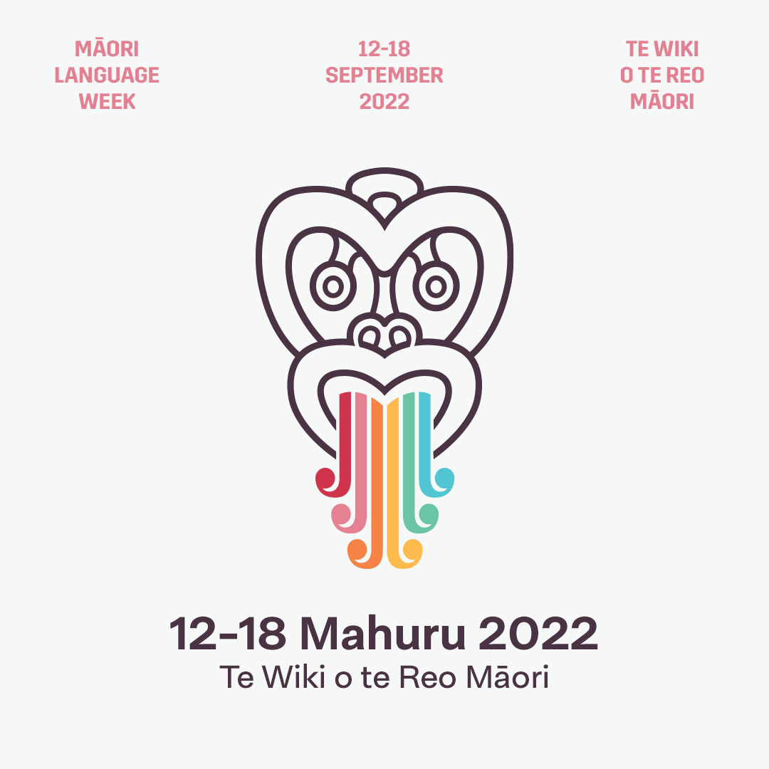

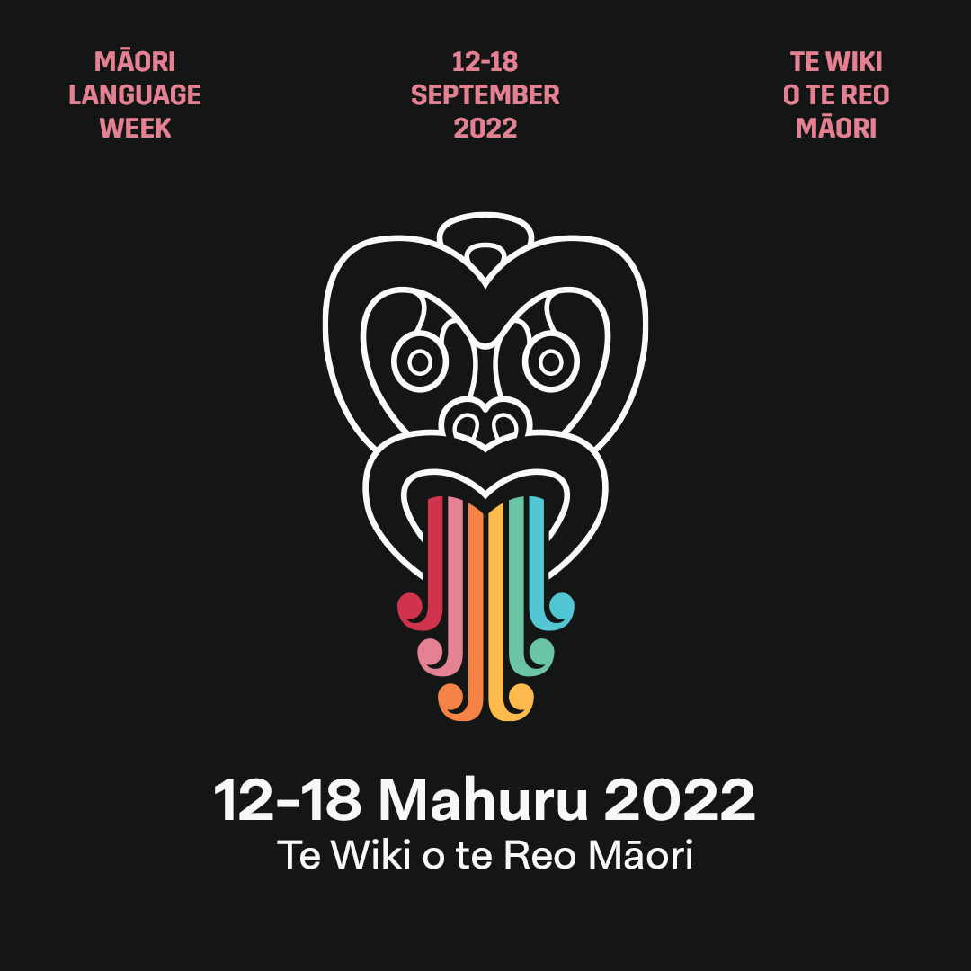

**Our Catholic Resources**

**1          Sign on and Sign Offs**

See Attachment

**2          Orange Miha Book -** PM Ryan

**Purple Tangihanga Book -** PM Ryan

Te Whānau Tapu (Holy Family) – Te Unga Waka, Newmarket, Auckland

Contact: see Manuel Beazley

**3          Weekly Readings in te reo Māori**

Diocese of Auckland Liturgy Office

<https://www.aucklandcatholic.org.nz/liturgy-prayer/te-reo-in-the-liturgy/>

**4          Māori in the Liturgy -** NLO Danny Karatea-Goddard

Catherine you have this at your finger tips.

**5          Mass in te reo Māori  - Priests Parts -** NLO Website

Catherine you have this at your finger tips.

**6          Te Ara a Maria Resources and Mō Maria -** NLO Website

Catherine you have this at your finger tips.

**7          Te reo Māori Glossary of Catholic Terms**

Diocese of Palmerston North Website

<https://pndiocese.org.nz/maori/glossary/>

**8          Catholic Māori Resources**

Diocese of Palmerston North

<https://pndiocese.org.nz/maori/resources/>

**9          Check out Manual Beazley Resources available from the Diocese of Auckland**

