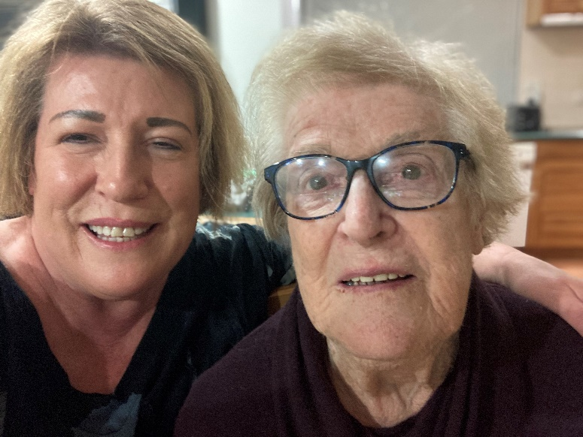
Jude McKee, Family carer: Now it’s my turn
People sometimes ask Jude McKee if her mother should be in a home. Jude says she replies, “She is in a home. She’s in her own home.”
Jude has been reflecting on her experience caring for her mother, who has dementia, as part of her pastoral ministry formation with the Archdiocese of Wellington Launch Out programme.
“It’s sad but I can count on my hand how many people from our parish have come into this house to see how she is doing at home. We have a group that visits people in hospital, but many people are in the community.”
Jude and her mother receive some in-home support, but with changing staff and rosters it can be hard to build up a relationship and sense of rapport.
“There’s things you look after yourself. I’ve got showering down to a fine art. Reminding Mum that she needs to eat, so even when I’m at work I’ll ring her and say, ‘In your lunchbox or on the bench, make yourself a cup of tea and have that now’.
“I look after her medications for her, and sort out getting her off to bed. If she’s up too late, she just gets beyond managing, so she’s got her routine. Mum starts packing up at 8.00 or 8.30 and that is just how it is. So you’ve just got to get used to it.”
Jude has learned to take life more slowly. “Time means nothing. If you’re going anywhere or doing anything, you have to give yourself mountains of time, because there’s no such thing as rushing.”
She has learned to treasure moments when her mother’s memory is clear. “People say that people with dementia remember things from earlier in their lives more than what they had for lunch today. But actually, no, Mum doesn’t remember it. So what I find is when she gets on to something that triggers a memory, I jump onto that memory, and I call that being in the present because to me that’s a lucid time when she’s remembering something and recalling it.
“So being in the present with her is better than doing the washing and the dusting. Sometimes I just have to put those things aside and be in the present with her, and I just grasp those moments. And it’s a real thrill to be in those lucid, present moments because they are so few and far between.”
One day at Mass Jude became aware of a voice saying to her, Just be in the present. “And I thought, ‘Wow, where did that come from?’ And it made me very aware of those moments with her, and to not let them escape or disappear unattended because they are pretty special.
“That’s the thing about respecting and supporting life. It’s not just life in general. It’s her life. It’s about respecting everything that Mum’s ever done for me. Here she is, this beautiful lady who brought me into the world, and now it’s my turn.”
Caring for her mother at home has required some sacrifices. “You have to give up some of your life to be able to do this. At first, you think you’re going to be able to do everything, and then in time, you work out, ‘No, I have to give up some things to respect and support her.’ And it maintains her dignity and she knows she’s loved and important.”
Jude takes strength from knowing it was her father’s dying wish that she took care of her mother. “You know, Jesus was on the cross and he said to John, ‘This is your mother’, and from that time on John looked after Mary in his home. So I feel it is our call to live out our faith by caring for our parents. It’s so easy to want to tuck everyone away, but that’s not necessarily what we are called to do.”
She looks to the example of Christ. “Jesus did all these things. He visited the sick, he cared for the dying, he went to his friend’s grave and he cried there. We need to get a real grasp on aroha. If we can bring that into our communities, we would be able to reach much further and actually provide much more real comfort and support than rocking up with a bag of groceries and dropping it at the door. We tend to rush things just like we rush our secular lives. But we need to stop doing that.”
Jude says sometimes, when they are out of the house, her mother will tell her that she can’t picture what the house looks like. “I say, ‘Oh Mum, when you walk in the door you will know where everything is.’ And she does, she walks in the door and she does know where everything is in this house. So it’s a comfort place for her, so for me to be able to keep her in her comfort place is huge.”

